DAILY ONLINE ACTIVITIES SUMMARY

|  |  |  |  |  |  |  |  |
| --- | --- | --- | --- | --- | --- | --- | --- |
| **Date:** | **29/05/2020** | | | | **Name:** | **Kavya.R.Shetty** | |
| **Sem & Sec** | **VI , A sec** | | | | **USN:** | **4AL17CS042** | |
| Online Test Summary | | | | | | | |
| **Subject** | | **OR IA.2 Test** | | | | | |
| **Max. Marks** | | **30** | | **Score** | | **30** | |
| Certification Course Summary | | | | | | | |
| **Course** | **Introduction to Information Security** | | | | | | |
| **Certificate Provider** | | | **Great Learning Academy** | **Duration** | | | **5.5 hrs** |
| Coding Challenges | | | | | | | |
| **Problem Statement:**   1. Write a python program to calculate the number of lowercase and uppercase letters in a string. 2. given these 3 strings write a function that detects whether str3 is a valid shuffle of str1 and str2. 3. write a c program to solve a system of linear congruences by applying the Chinese Remainder Theorem. 4. Write a Java Program to check whether the given number is Armstrong number or not. 5. Write a Java Program to find longest substring without repeating characters in a string. | | | | | | | |
| **Status: Completed** | | | | | | | |
| **Uploaded the report in Github** | | | | **Yes** | | | |
| **If yes Repository name** | | | | https://github.com/kavya-shetty765/DAILY-STATUS | | | |
| **Uploaded the report in slack** | | | | **Yes** | | | |

# Online Test Details:

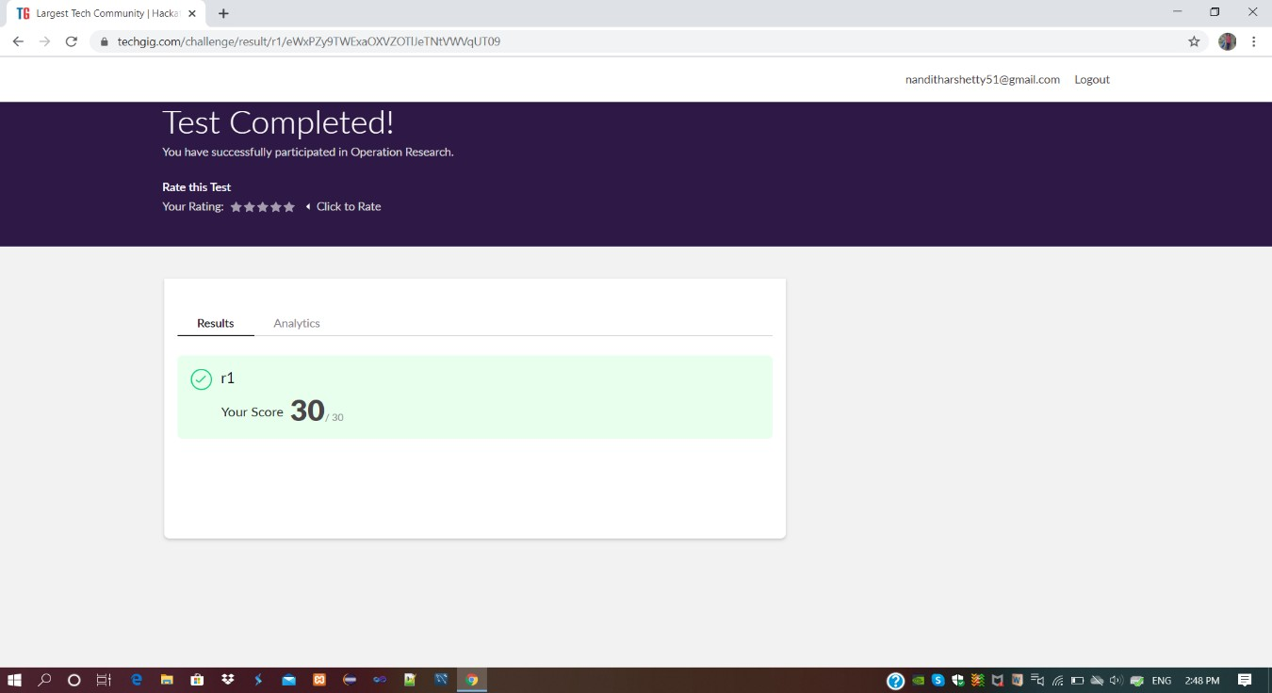

**Certification course Details:**

**Introduction to Information Security:**

Today I had a “Stanford webinar” In that I learnt,

* Security lessons from big name Breaches by – Neil Daswani
* Hash, Hack, Codes: Emerging trends in cyber Security – Dan Boneh

Refer GitHub account for Detailed information: <https://github.com/kavya-shetty765/DAILY-STATUS/tre_e/master/29-05-2020>

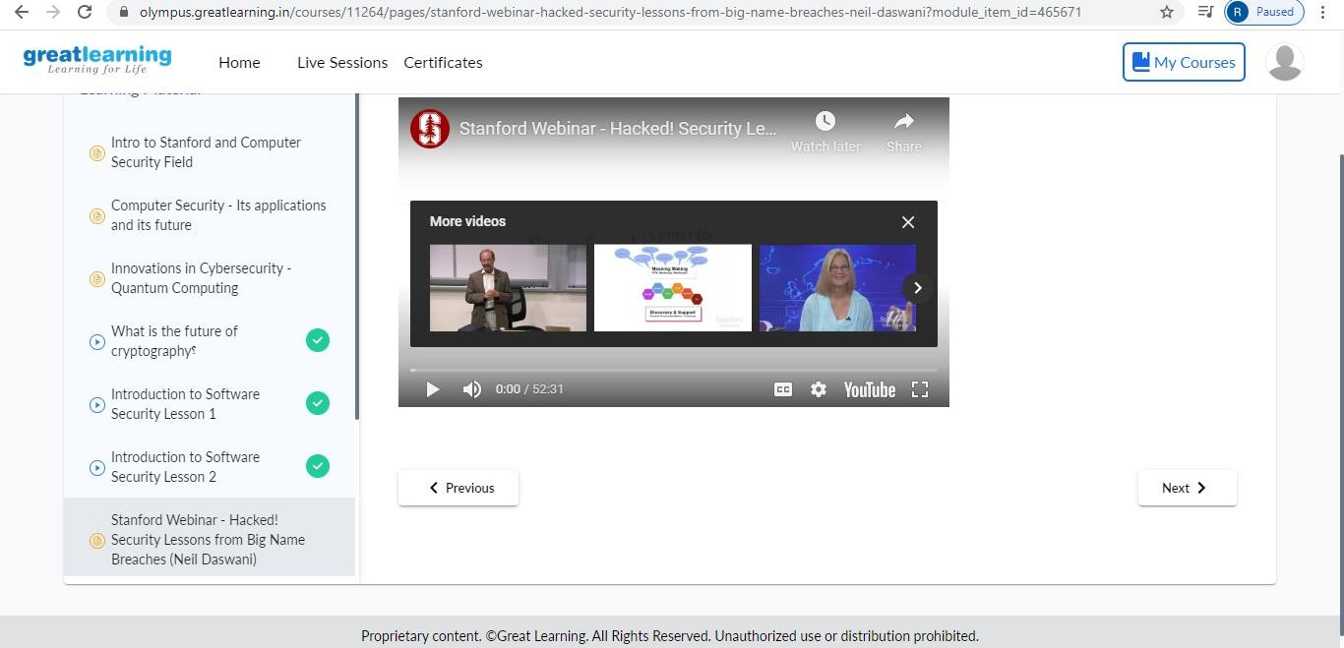

# Coding Challenge Details:

Refer the GitHub for Detailed Information:

<https://github.com/kavya-shetty765/DAILY-STATUS/tree/master/29-05-> [2020/ONLINE%20CODING](https://github.com/nandithashetty/DAILY-STATUS/tree/master/29-05-2020/ONLINE%20CODING)

The same report is also available in : <https://github.com/kavya-shetty765/DAILY-STATUS/tre_e/master/29-05-2020>